
Assessment Cover Page

Student Full Name
Bruno Stefani Esposto
Student Number
sba26087
Module Title
Strategic Thinking
Assessment Title
CA 1 – Capstone Project Proposal
Lecturer/Supervisor
Taufique Ahmed
Assessment Due Date
25/10/2026
Date of Submission
23/10/2026

Use of AI Tools
I acknowledge the use of [enter name of the AI tool you used] for the purpose of [provide a brief explanation of how you used the tool].
Declaration
By submitting this assessment, I confirm that I have read the CCT policy on academic misconduct and understand the implications of submitting work that is not my own or does not appropriately reference material taken from a third party or other source.
I declare it to be my own work and that all material from third parties has been appropriately referenced.
I further confirm that this work has not previously been submitted for assessment by myself or someone else in CCT College Dublin or any other higher education institution.

Contents
1. Project Title 1
2. Introduction 1
3. Problem Definition 2
4. Aim and Objectives 2
4. 1 Aim 2
4.2 Objectives 2
5. Scope 3
6. Methodology 3
6.1 Data Collection and Preparation 3
6.2 Predictive Modelling 3
6.3 Model Evaluation 3
6.4 Architecture Diagram 4
7. Data Sources 4
8. Expected Deliverables 4
9. Project Timeline 5
10. Ethical and Legal Considerations 5
References 6
Appendix 7

1. Project Title
To be defined.

2. Introduction
Public procurement gives businesses of all sizes the opportunity to supply goods and services to public sector organisations. In Ireland, these opportunities are advertised through the national eTenders platform. The Office of Government Procurement (OGP)’s analysis of 2018 covered 4,413 tender notices, an average of about 370 a month, with a median estimated contract value of €100,000 (OGP, 2021). With this volume of notices, monitoring and assessing opportunities is a demanding task, especially for smaller suppliers with limited staff and time.
Making it easier for small and medium-sized enterprises (SMEs) to access public procurement opportunities is widely seen as supporting inclusive growth and effective competition for public contracts (OECD, 2018). However, identifying suitable opportunities and deciding which tenders to pursue can require considerable time and resources, particularly for SMEs with limited staff available to monitor and assess tender notices (Swarnkar et al., 2009). Understanding the level of competition associated with different tenders could provide suppliers with additional information when deciding which opportunities to investigate further. A tool that indicates the likely level of competition could help them prioritise tenders and allocate bid-preparation resources more effectively.
Competition is also an important aspect of public procurement. The number of bids received is commonly used as a measure of competition in a tender (Görgün, Kutlu and Taş, 2020) and may help suppliers understand the competitive environment before deciding to bid. Previous studies show that analysing historical data may reveal characteristics associated with different levels of bid competition (Tátrai, Vörösmarty and Juhász, 2024). Data analytics and predictive modelling have been applied in public procurement to investigate bidding behaviour and predict number of bidders. For example, Görgün, Kutlu and Taş (2020) explored methods for predicting the number of bidders in public procurement, and Oo et al. (2024) used machine learning models to predict the number of bidders in competitive construction bidding.
This project proposes to analyse open data published by Ireland's Office of Government Procurement (OGP, 2026) to investigate whether tender characteristics such as estimated contract value, contract type and Common Procurement Vocabulary (CPV) codes can help predict whether a tender is likely to attract high or low competition. Classification models will be developed and evaluated to assess their predictive performance and explore their potential to support suppliers in screening tender opportunities.

3. Problem Definition
Suppliers participating in public procurement must decide which tender opportunities are worth investing time and resources in. Preparing a tender response can involve reviewing requirements, gathering documentation and developing a suitable offer. For SMEs, this creates a screening problem. With hundreds of tender notices published each month on eTenders, they must decide which opportunities justify the effort of preparing a bid. Identifying and pursuing tenders requires resources and tendering capabilities, which can affect suppliers' participation and performance (Flynn, 2017). However, information about how many competitors are likely to bid is not readily available when this decision is made, so suppliers often rely on experience or intuition. Without insights into likely level competition, suppliers may spend valuable time preparing bids for highly competitive tenders while overlooking opportunities that may attract fewer bidders. A better-informed screening process would allow SMEs to prioritise their effort, and it could also support wider participation in public procurement.
Data analytics and predictive modelling could help address this problem by turning historical tender data into evidence to support suppliers when screening opportunities. Public procurement data contains information of past tenders, such as estimated contract value, contract type and CPV code, as well as the number of bids each tender received. Previous research has explored how these characteristics relate to tender competition and how predictive modelling can be used to estimate the number of bidders (Görgün, Kutlu and Taş, 2020; Oo et al., 2024). Using Irish OGP data, a classification model could learn from past tenders to predict whether a new tender is likely to attract high or low competition, based on information available when the tender is released. This would give businesses an additional, evidence-based indicator when deciding which tenders to pursue, helping them prioritise their time and resources. The model would support tender screening rather than replace supplier judgement, as it provides an estimate of likely competition and not a prediction of bid success.

4. Aim and Objectives

4. 1 Aim
The overall aim of this project is to investigate whether historical public procurement data can be used to predict the likely level of competition for a newly published public tender and how these predictions could support suppliers when screening opportunities.

4.2 Objectives
1. Examine and prepare public procurement data, handling any missing values and conducting exploratory data analysis.
2. Develop and compare machine learning classification models that predict whether a tender is likely to attract low or high competition.
3. Evaluate model performance using appropriate metrics.
4. Business objective: Assess whether the predictions could provide suppliers with an additional indicator of likely competition to support the screening and prioritisation of tender opportunities.

5. Scope
The project will analyse the public procurement dataset published by the Office of Government Procurement, using tender publication records with a known number of bids received. It will include data preparation and exploratory data analysis, and the development and comparison of machine learning classification models to predict the likely level of competition. The models will be evaluated and the usefulness of the predictions for supplier tender screening will be discussed.
The project will not develop a fully operational commercial application, predict whether a supplier will win a tender, or measure the actual impact of the predictions on suppliers’ bidding decisions or success rates.

6. Methodology

6.1 Data Collection and Preparation
The project will use historical Irish public procurement data published by the Office of Government Procurement. Python and the Pandas library will be used to load, clean and prepare the dataset, including handling missing values and outliers, checking for inconsistencies, and selecting appropriate features. Exploratory data analysis will be conducted using descriptive statistics and visualisations created with Pandas, Matplotlib and Seaborn to understand the distribution of bid counts and the characteristics of the tenders. The target variable will be defined by categorising the number of bids received into two classes representing low and high competition. The distribution of these classes will be examined to assess whether class imbalance is present.

6.2 Predictive Modelling
Python will be used to develop two classification models. The proposed algorithms are Logistic Regression and Decision Tree. These models were selected to compare different approaches to predicting whether a tender is likely to attract low or high competition. Another classification model such as Random Forest may also be included if time allows to compare its results with the other models. The dataset will be divided into training and testing sets models so that they can be trained and then tested on data they have not seen before. Cross-validation will be used to help assess model performance and compare the models.

6.3 Model Evaluation
The models will be compared using accuracy, precision, recall, and F1-score to get a better understanding of their performance rather than relying on accuracy alone. Confusion matrix will also be used to analyse the predictions made by each model. The strengths and limitations of the models will be discussed along with their potential usefulness for supplier tender screening. The evaluation will help determine which model performs better and whether its predictions could provide useful information to suppliers when deciding whether to pursue a new tender publication.

6.4 Architecture Diagram

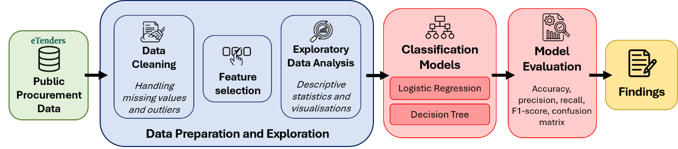
Figure 1: Architecture diagram of the proposed project.

7. Data Sources
The Public Procurement Open Data dataset published by Ireland's Office of Government Procurement will be used in this project. The dataset includes records of procurement notices, contract awards, procurement procedures and related information across public sector organisations (OGP, 2026). It covers published competitions from 1 January 2013 to 30 June 2026. The file used in this project contains approximately 87,400 records and 31 variables, providing a substantial source of historical data for analysis.
The dataset is relevant to the business problem because it contains the number of bids received together with characteristics such as CPV code, estimated contract value and contract type that are known when a tender is published and can therefore be used as predictors. The dataset is publicly available through data.gov.ie and is licensed under the Creative Commons Attribution 4.0.

8. Expected Deliverables
By the end of Semester 2, data preparation and exploration are expected to produce a cleaned version of the dataset, while descriptive statistics and visualisations will be used to identify patterns in tender characteristics and the distribution of bid counts. These findings will help determine the threshold used to classify tenders into low or high competition categories.
The two proposed classification models (Logistic Regression and Decision Tree) will be developed and evaluated using accuracy, precision, recall, F1-score and confusion matrices. Models evaluation results will be delivered as part of the project. The findings will be presented in a final project report addressing the proposed business problem. A Jupyter Notebook containing the Python code and the steps taken throughout data preparation, analysis and modelling will also be delivered.

9. Project Timeline
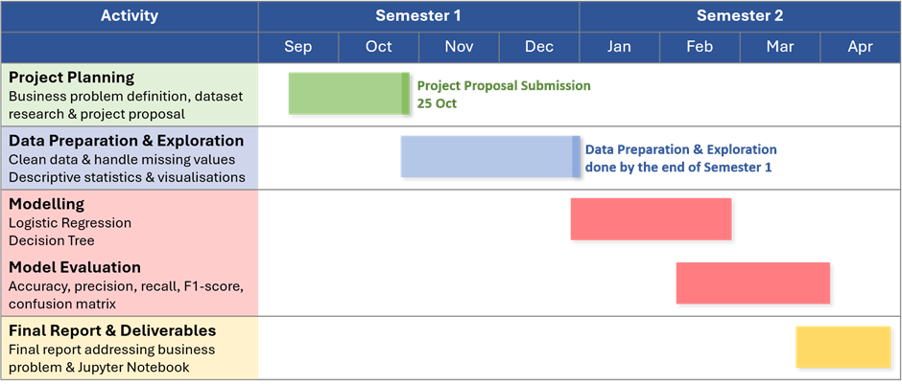

10. Ethical and Legal Considerations
Identify relevant ethical, privacy, data protection, security and data-use considerations associated with the project. Explain how these will be appropriately addressed, including permissions for accessing and using the selected data.

References
Flynn, A. (2017) “Re-thinking SME disadvantage in public procurement,” Journal of Small Business and Enterprise Development, 24(4), pp. 991–1008. Available at: https://doi.org/10.1108/JSBED-03-2017-0114.
Görgün, M.K., Kutlu, M. and Taş, B.K.O. (2020) Predicting the Number of Bidders in Public Procurement. Institute of Electrical and Electronics Engineers Inc. Available at: https://doi.org/10.1109/UBMK50275.2020.9219404.
OECD (2018) SMEs in Public Procurement: Practices and Strategies for Shared Benefits. OECD Publishing (OECD Public Governance Reviews). Available at: https://doi.org/10.1787/9789264307476-en.
OGP (2021) Minister of State Smyth welcomes Office of Government Procurement report on public tendering and spending, gov.ie. Available at: https://www.gov.ie/en/office-of-government-procurement/news/minister-of-state-smyth-welcomes-office-of-government-procurement-report-on-public-tendering-and-spending/ (Accessed: October 10, 2026).
OGP (2026) Contract Notices Published on eTenders - data.gov.ie. Available at: https://data.gov.ie/en_GB/dataset/contract-notices-published-on-etenders (Accessed: October 10, 2026).
Oo, B.L. et al. (2024) “Predicting the Number of Bidders in Construction Competitive Bidding Using Explainable Machine Learning Models.” SSRN. Available at: https://doi.org/10.2139/ssrn.4845683.
Swarnkar, R. et al. (2009) “Prioritising Tendering Activities for small to medium-sized enterprises (SMEs),” 2009 IEEE International Technology Management Conference (ICE). 2009 IEEE International Technology Management Conference (ICE), Leiden: IEEE, pp. 1–7. Available at: https://doi.org/10.1109/ITMC.2009.7461423.
Tátrai, T., Vörösmarty, G. and Juhász, P. (2024) “Intensifying Competition in Public Procurement,” Public Organization Review, 24(1), pp. 237–257. Available at: https://doi.org/10.1007/s11115-023-00742-0.

Appendix

If you have used AI tools in your work, you must include screenshots of your requests in the appendix.
The appendix serves as a repository for additional or supplementary information that is deemed too extensive or detailed for integration into the main body of the text. This supplementary content can encompass data tables, charts, graphs, questionnaires, or any other supporting materials that contribute to a comprehensive understanding of the research.
If you haven't used AI tools and there's no need for supplementary data, you can remove the appendix section entirely.

